www.ggeaca.org

Once again Commissioner McDaniel goes against the
Estates Residents vested rights to maintain their quality of life on 4th St NE to help a Developer.
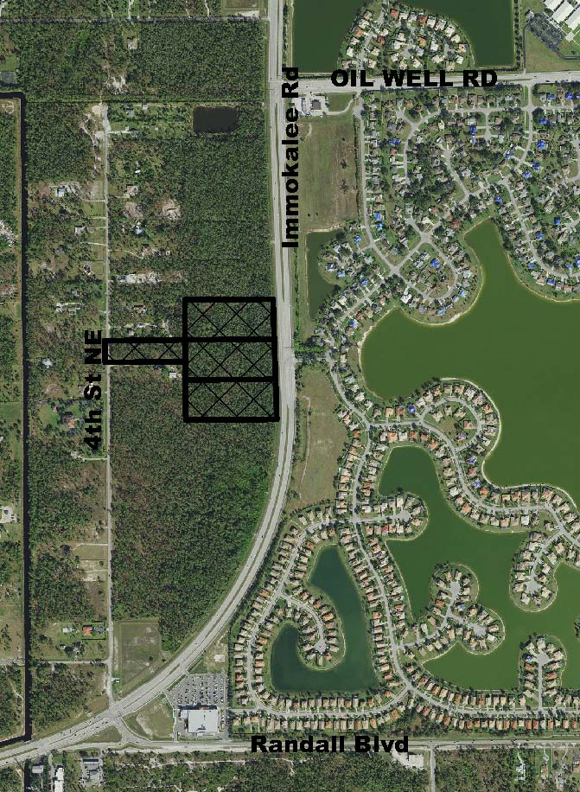
Agenda Item 9.D. on the on the BCC Meeting of 27 Oct 2020, was the First Transmittal Hearing for the proposed Immokalee Road - Estates Commercial Subdistrict. PL20160000221. Watch the video.

This is known as a Growth Management Plan-Large Scale- Amendment or GMPA. It is part of the process to Modify/Ammend the Golden Gate Area Master Plan- Rural Sub Element (Link1) (Link2, scroll down to Rural Element).

This is the First Step in changing a parcel of land within Golden Gate Estates designated for Residential Single Family Home use to a Developers Commercial / Retail Activity. The proposed activity has to be presented to the Estates Residents, go the Planning Commission for further review and then presented to the BCC for acceptance.

The residents of 4th St NE had met with Commissioner McDaniel and requested that the parcel located on 4th St NE should have no access to the Commercial / Retail activities being proposed by Barron Collier, the owner of the project.

After going through the Planning Commission review, their recommendation to the BCC was “Eliminate access from 4th St NE”. See Executive Summary

During the BCC meeting Commissioner Penny Taylor asked the Developer/Owner -Barron Collier- did they need access to 4th St NE for any type Emergency or Evacuation Access – they said NO. There would be enough access on Immokalee Rd to provide for Emergency or Evacuation Access.

But Commissioner McDaniel still insisted that the Developer needed access to 4th St NE by suggesting that a gated road be constructed For Evacuation Purposes Only????????? And that it be included in the Transmittal Document.
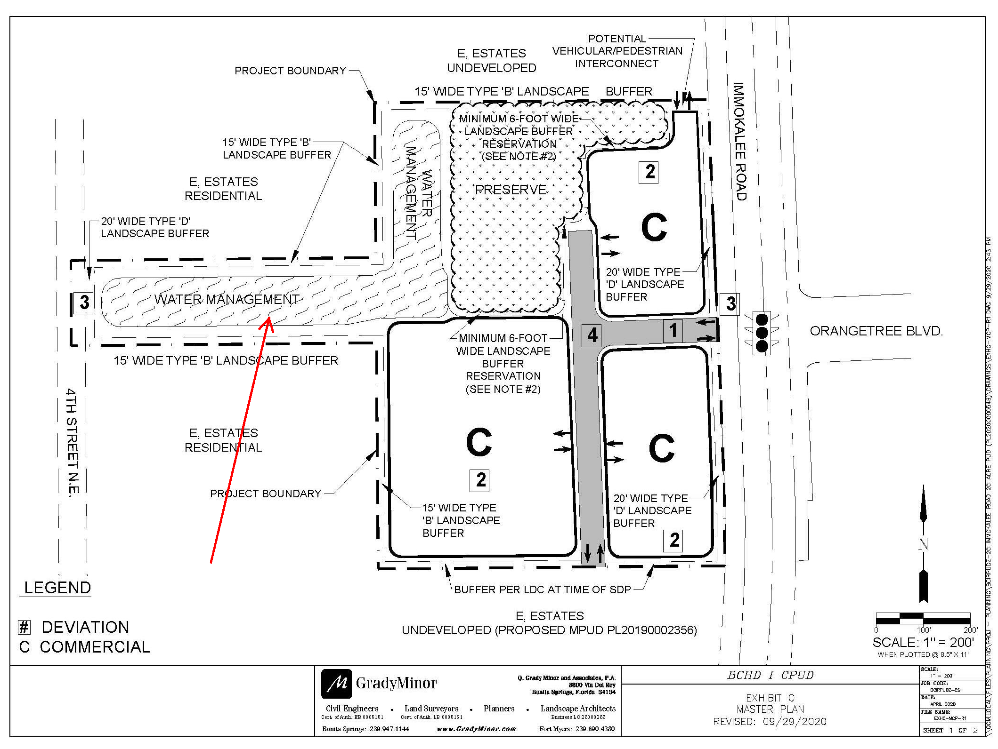
This was a DISGUISED ATTEMPT to get a road installed under the pretense of an evacuation road. Then OVERTIME- the gate would come down and be used for access. NOT ACCEPTABLE.

This is the ACCEPTABLE SITE PLAN for this proposed Barron Collier Development for the 4th St NE Parcel:
- Natural Vegetation
- Buffer
- Water Management
- NO ACCESS TO 4TH ST NE.

The PUD application is identified as PL20200000546. Click to see the application documents. NOTE: the Property Owner/Developer is INCORRECTLY listed as Crown Management on the Collier County website. It is Barron Collier.

GGEACA will keep you posted…………

